Bright Beginnings with Early Steps
SUMMER CAMP 2024
Child/Children’s Name:

For ages 5-10 years old (Child must be 5 on or before May 30, 2024)

The summer camp weekly fee is $175.00 per child per week. Please select the weeks you will need care below.
** If you do not register for the weeks of summer camp that you would like to attend, you will be billed for the entire summer**

This is a 9 week contract, and you will be billed for ALL registered weeks, without exception.

We will be going to swim throughout the summer. Please select one of the following:
My child can swim

My child can swim with life jacket only
June 3rd- June 7th -“Exploring Soil Life”
June 10th- June 14th -“Seeds and Science”
June 17th- June 21st -“Plant Health and Nutrition”
June 24th- June 28th -“Pollinators and Flowers that
attract them”
July 1st – July 3rd -“Review”
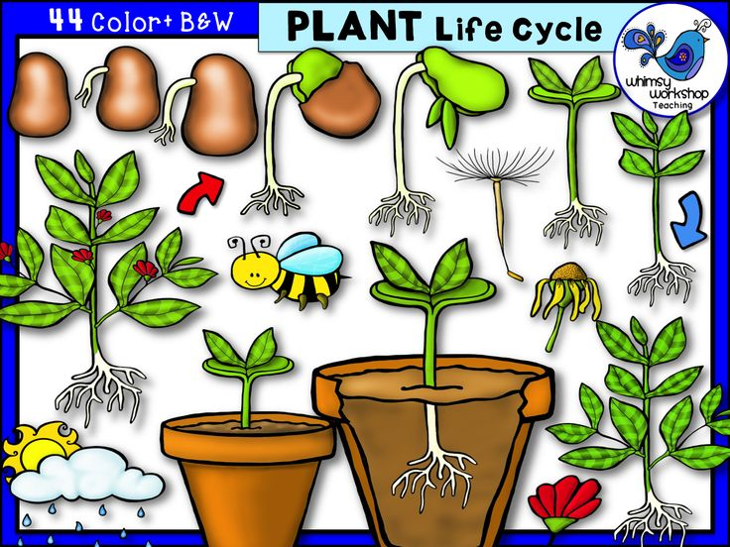
-Holiday to be scheduled prior to start of camp
July 8th- July 12th -“Worms”
July 15th- July 19th -“Compost”
July 22nd- July 26th -“Harvesting”
July 29th- August 2nd -“Produce and Nutrition”

Every Friday will be a “Fun Friday”! We will be going on field trips, to the park, or to swim!
Summer Camp Registration Fee (Per Child): $100.00
Payment Date: / /
Check #
Cash:
Payment taken by:

